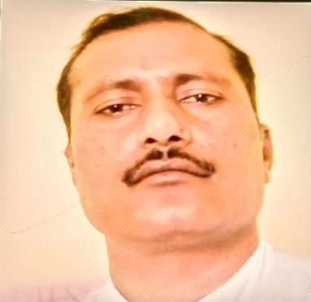
Dr. Mukesh Kumar
Principal
Education Department, Nimbus School of Education, Dehradun (U.K)
Contact:
Email-mukeshkumar2276@gmail.com
Phone: +91-9528186584
Education:
Ph.D. in Education (2011) from C.C.S University Meerut.
M.Ed. in 2005 from Rajasthan University Jaipur Raj.
M.A in Sanskrit (2014) from C.C.S University Meerut.
B.Ed. in 2003 from C.C.S University Meerut.
B.A.in 2000 from C.C.S University Meerut.
Teaching:
Teaching of Sanskrit
Academic Experience:
15 years’ teaching experience in B.Ed. college
Professional Experience:
Nimbus School of Education
Nimbus Academy of management

